CORE VALUES
The Core Value for this month is the 1st point of the Scout Law - FRIENDLY
The core value highlighted this month is:
August's point of the Scout Law, FRIENDLY, will use the theme, #CUBSCOUTS.
A SCOUT IS FRIENDLY
A Scout is a friend to everyone, even people who are very different from him.
HOW DOES “LET THE GAMES BEGIN” RELATE TO THE FIRST POINT OF THE SCOUT LAW, TRUSTWORTHY??
A Scout is a friend to all. #CubScouts is trending! Communicate in new ways with computers and more to spread the word on how much fun Scouting can be. Let the boys friendstorm who they would like to invite to join Cub Scouting..
Per our Founder, Lord Baden-Powell
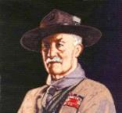

Note – The original Scout Law published in 1908 had nine points. In 1910, the BSA added Brave, Clean, and Reverent. In 1911 B-P added Clean to his original list.
A SCOUT IS A FRIEND TO ALL,
AND A BROTHER TO EVERY OTHER SCOUT, NO MATTER TO WHAT SOCIAL CLASS THE OTHER BELONGS
If a scout meets another scout, even though a stranger to him, he must speak to him, and help him in any way that he can, either to carry out the duty he is then doing, or by giving him food, or, as far as possible, anything that he may be in want of. A scout must never be a SNOB. A snob is one who looks down upon another because he is poorer, or who is poor and resents another because he is rich. A scout accepts the other man as he finds him, and makes the best of him -- "Kim," the boy scout, was called by the Indians "Little friend of all the world," and that is the name which every scout should earn for himself..
(Scouting For Boys, 1908)

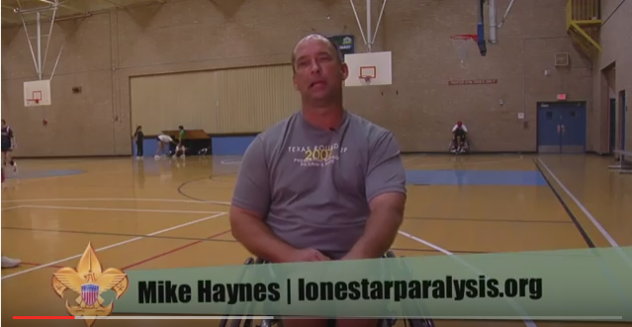
In this video, the "Believe It Live It" team speaks with Mike Haynes, a wheelchair athlete. Mike made up his mind when he was shot and became a paraplegic to be FRIENDLY too thers and not let his being in a wheelchair depress others. By his actions to others who are wheelchair bound Mike truly exemplifies the 4th point of the Scout Law - FRIENDLY. He is truly a friend to all. Go to: https://www.youtube.com/watch?v=PBZfWqPZjtA

